Pokedex Project

**Starting point**

* List of pokemon and information
* Able to search for specific pokemon
* Create a pokemon
* Pokemon database: Pokemon, Moves, Types
* TeamBuilder, able to choose up to 6 pokemon and save it as team

**Code Structure**

* GUI Layer
* Database Layer
* Logic Layer

**Definition of Done- MVP**

* Create a pokedex that displays the list of all pokemon
* Able to view information on each pokemon when selected
* Able to search for specific pokemon within the pokedex

User stories

* As a user, I want to search through the list of all pokemon, to see information
* As a user, I want to be able to create my own pokemon so that I can view it within the pokedex
* As a user, I want to be able to search for a specific pokemon, so I can see more details about the pokemon
* As a user, I want to be able to play a pokemon related game so that I can pass time and enjoy myself
* As a user, I want to be able create my own account on the application so that I can use the application
* As a user, I want to be able to sign into the application with my login details so that I can use the application with my personal account

**SPRINT 0**

**Sprint goal:**

* Create a pokedex database and connect it to c# using entity framework
* Create a product backlog list on trello

**Sprint review**

* Able to create the product backlog list for project on trello
* Blocker: However, was not able to create database because I was preparing for tomorrow’s interview

**Sprint retrospective**

What went well:

* Created a product backlog list on trello which describes what needs to be completed on trello

Improvements:

* Nothing at the moment

Action Plan for tomorrow:

* Create my pokedex database
* Connect it to database with entity framework
* Get started on the mvp

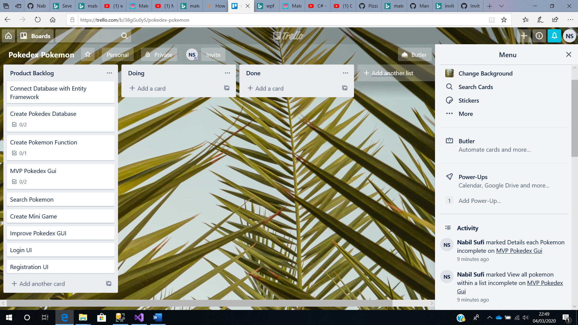

**SPRINT 1**

Phone interview and was unwell throughout the day, nothing was done.

Burndown chart work rate low…. Emotion graph low

**Sprint goal:**

* Create my pokedex database and create pokemon table
* Connect it to database with entity framework
* Get started on the MVP

**Sprint review**

* Achieved nothing during this sprint because of 2 blockers
* 1st blocker, the phone interview. Was focussed on phone interview prep and thus neglected project work
* 2nd blocker, after the phone interview, I was not feeling well and was unable to get any work done

**Sprint retrospective**

What went well:

* Nothing went well as I have not made a start to the project

Improvements:

* Need to make a start on the project otherwise, I will not fulfil my backlog list

Action Plan for tomorrow:

Same as before

* Create my pokedex database
* Connect it to database with entity framework
* Get started on the mvp

**SPRINT 2**

**Sprint goal:**

* Sprint backlog, a list of user stories with acceptance criteria
* Output of sprint review:  The list of backlog items "done" in this sprint, actions for any items not “done”
* Sprint retrospective:  A list of things that went well, improvements and action plan.

Sprint Backlog

Create pokedex database and pokemon table. Connect it to c# using entity framework

**User Story 1**

As a user, I want to search through the list of all pokemon, so I can the variety of pokemon that is currently available on the pokedex.

Acceptance Criteria

* Able to see pokemon within the list
* Able to select specific pokemon and display its information

**User Story 2**

As a user, I want to be able to create my own pokemon and save it to the pokedex

* Able to insert information such as name and type when creating the pokemon
* When pokemon is created, I am able to see it within the pokedex available to view

**Sprint review:**

**Done**

* Created a pokedex database with a pokemon table within
* Connected my database with c# using entity framework
* Created a gui which displays all the pokemon available within the database
* Able to create custom pokemon and add it to the database
* Can display custom pokemon on pokedex

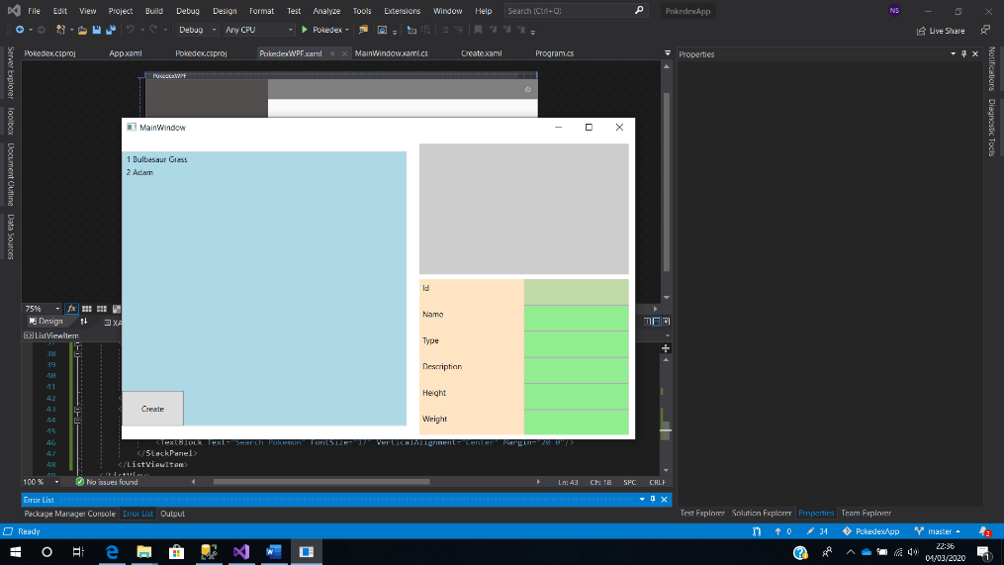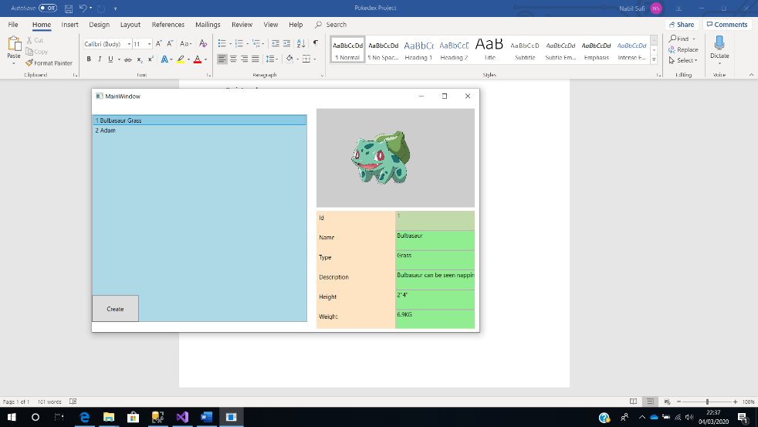

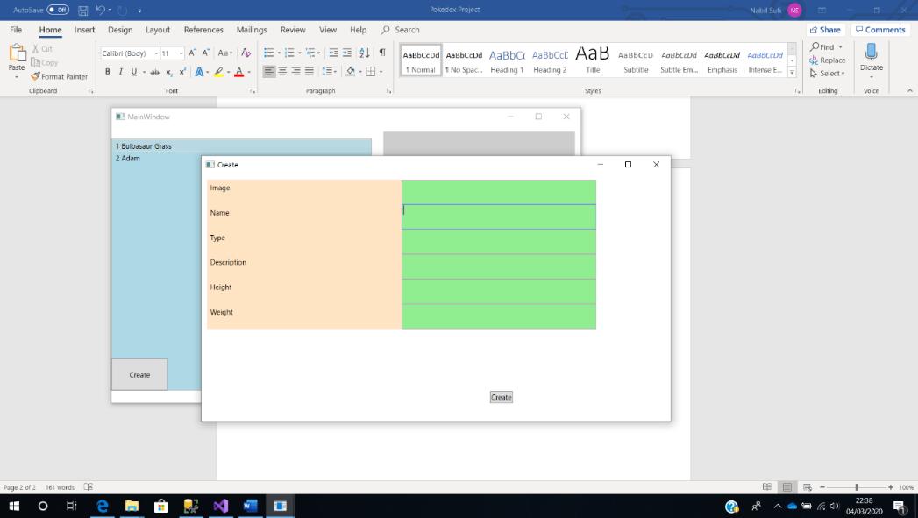

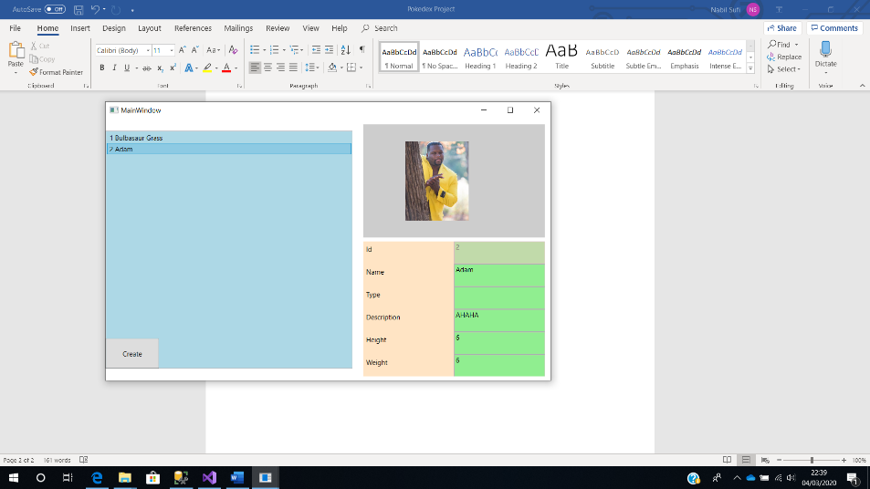

**Sprint retrospective**

What went well:

* Created pokedex database with pokemon table
* Was able to achieve my mvp of viewing and creating pokemon within the application
* Successfully made my first commit of github
* Was productive all day and got a lot stuff done compared to my previous sprints

Improvements:

* Need to improve the ui design of the gui
* And add more functionality to the application

Action Plan for tomorrow:

* Create a search bar functionality
* Improve the gui design

**SPRINT 3**

**Sprint Backlog**

Create a search bar functionality and improve ui design of application

**User Story 1**

As a user, I want to be able to search for a specific pokemon, so I can see more details about the pokemon

Acceptance Criteria

* Able to search for specific pokemon when name is typed
* Able to see a list of pokemon depending on the characters typed within search bar

**Sprint review:**

**Done**

* Able to create a search functionality which allows the user to find a specific pokemon that they’re looking for
* Have begun trying to improve the gui design

**Sprint retrospective**

What went well:

* Recent implementation of the search functionality works great. Able to see list of pokemon depending on the first character inputted into the search bar
* Improvement of GUI. Looks a lot better than previous version

Improvements:

* Need to improve the ui design of the gui
* And add more functionality to the application

Action Plan for tomorrow:

* Continue improvements of gui design
* Begin implementation of mini game

**SPRINT 4**

**Sprint Backlog**

Continue GUI improvements and make a start on mini game

**User Story 1**

As a user, I want to be able to play a pokemon related game so that I can pass time and enjoy myself

Acceptance Criteria

* Create pokemon rock, paper, scissors related game but with water, fire and grass
* Implement score, losses and draw functionality

**Sprint review:**

**Done**

* Have made more improvements onto the gui and also used material design package to implement transitions between each screen.
* Have completed game implementation of pokemon- rock, paper, scissors related game

**Sprint retrospective**

What went well:

* Mini game working smoothly
* Implementation of the GUI design is looking better

Improvements:

* Need to organise the class files and make it look a lot more clean
* Need to start commenting code

Action Plan for tomorrow:

* Add stats table and linked it to the pokemon table, so that the stats of each pokemon can be viewed on the gui
* Polish the design and implement sound and music throughout the gui
* Create unit tests for mini game

**SPRINT 5**

**Sprint Backlog**

* Create stats table within database
* Add stats button to the pokedex page, to view pokemon stats for each pokemon
* Implement sound and music within the gui
* Create unit tests for game

**Sprint review:**

**Done**

* Created stats table but however was unable to view data within gui due to time constraints and difficulty whilst implementing
* Implemented music within the game

**Sprint retrospective**

What went well:

* Created stats table and able to link it with pokemon table within database
* Implemented music In mini game
* Implemented sound in pokedex, e.g. able to listen to each pokemon’s unique sound
* Sorted class files within each respective folders
* Successfully created unit test classes for mini game

Improvements:

* Need to implement stats functionality so that it can be viewed onto the gui

Action Plan for future:

* Populate database with more pokemon
* Continue to improve the gui design
* Create a sign in and registration function for application

**Class Diagram**

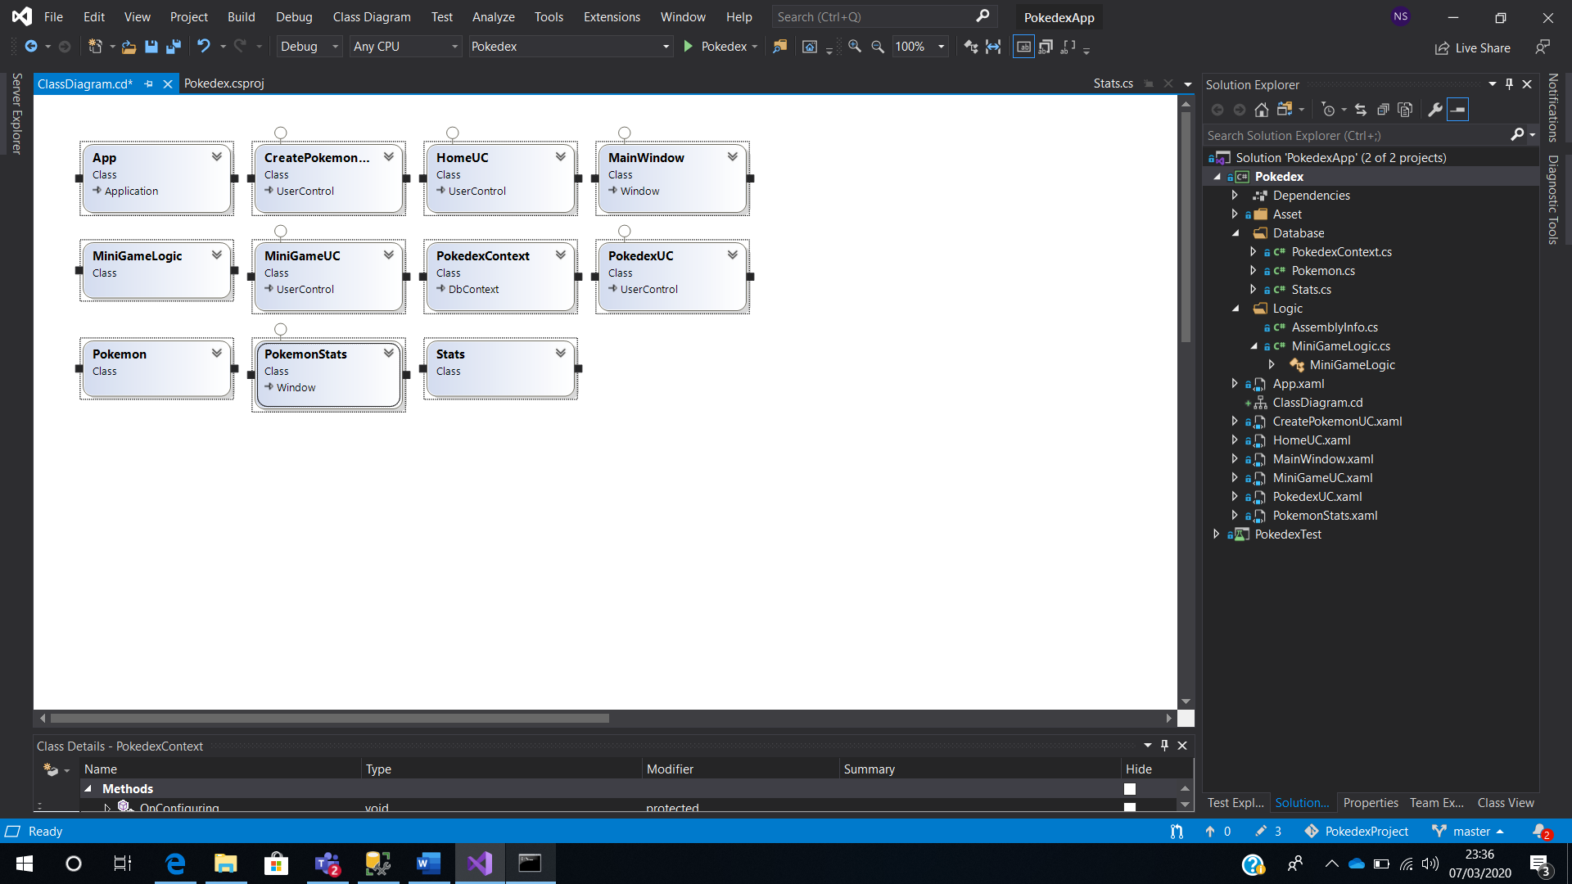

**Overall Retrospective**

During the process of this project, I have learnt how important it is to use a version control software such as github, so in case if something goes wrong with the project, you can always revert to your previous commit. What I would do differently is that I would create wireframes for the GUI so that I have a design to follow rather than trying to design the GUI blindly. Next, I plan on trying to implement the stats functionality of each pokemon within the gui, as well as, implementing a sign up/sign in functionality within the application. Overall, the project was a success because I was able to create achieve my goal of creating my mvp, as well as adding more functionality within the project, for example, the mini game.